The Coz McNooz
Summer/Fall 2012

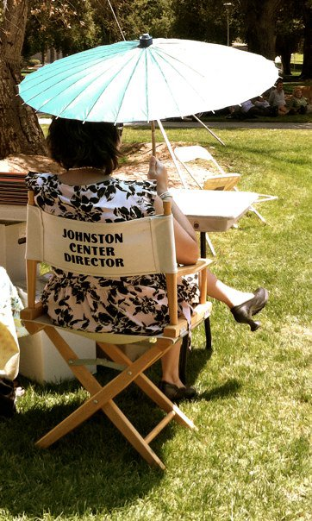Dobar Dan Johnstonians! That’s the standard greeting in Croatia, where I had the great privilege of spending two weeks in June. What a lovely country—beautiful landscape, delicious food, and spectacular wine. Even better than eating and drinking alongside the glistening Adriatic was speaking with Croatians. A few months before I flew to the Balkans, I got myself a Croatian language CD (Pimsleur—supposedly an outdated method, but I highly recommend it) and learned a few phrases. I figured it would be nice to know how to say: “it was nice meeting you,” “I understand a little Croatian,” and, since major eating was on the agenda, “that was delicious!” If you are a Croatian under forty years old, chances are you know English, often really well. And unlike citizens of many other European countries, Croatians have absolutely zero expectations that tourists will know their language. So, it confused and tickled them that I could speak even the most basic words and phrases. Needless to say, I was filled with pride and tickled as well. More importantly, the (admitted minimal) competency I had speaking with Croatians made me feel more connected to the people and less nervous about navigating my way around the country. It didn’t necessarily make me feel like less of a tourist—indeed, I have no quarrel with being a tourist—but, well, it made me feel like a more respectful one. It was very important for me that wherever I travelled throughout the country, the people understood that I saw them as not part of some pretty landscape that was essential for my holiday as a privileged American. Rather, I wanted it to be clear that their humanity was integral to my experience.

My time in Croatia made me think a lot about our students and the importance of their own cross-cultural experiences. Granted, I was on a two week, fairly lavish vacation, not a study abroad semester filled with intensive language classes, internships, research, and home stays. But just having this experience reminded me of why the cross-cultural, still more often than not manifesting as study abroad, remains central to a Johnston education. Of the many lessons that a cross-cultural experience can offer students, surely learning to be a better, more respectful tourist, traveler, and citizen of the world is one of them, no?

I’m pleased to say that, while a cross-cultural experience doesn’t have to mean leaving the country, our students continue to use the Study Abroad program, with its attendant immersive language study, as their primary means of fulfilling this part of their Johnston emphasis. Our students continue to travel everywhere from Prague to Ghana to Indonesia. In this issue of The Coz, we highlight our own homegrown study abroad program “The Johnston Integrated Semester in Oaxaca and Guatemala” led by Professor Patricia Wasielewski. The class seems to me, as an observer, to just keep getting stronger and stronger, building on the rich scaffolding of past classes, Pat’s deep connections in these countries, and her ongoing effort to make the class as intellectually and culturally rich and community-minded as possible. Pat’s commitment to alumni participation in the class is also what makes this class strong. This past spring, two alumni who previously traveled with the class as students, returned as paid assistants. These alumni assistants also returned to Johnston for the May term Oaxaca class, helping the students put on their regular celebratory event.

Granted, most alumni can’t spend a semester in Mexico and Guatemala with Johnston students. But there are many different ways to connect with the community, and we’re getting better at creating opportunities every day. I’m so pleased that we now have a variety of alumni activities happening across the country and in the virtual realm, some large, some small, and some that just simply happen organically. This summer’s seminar on Ovid’s Metamorphoses at Asilomar conference center, led by Bill McDonald and current senior Rachel Reynolds, was a grand success. Indeed, the seminar was such a hit that several members will reunite at this year’s CIEL conference (Consortium of Innovative Environments in Learning), held at Alverno college in October, for a presentation on the theme of alumni development. Given the impact of this alumni event, I dedicate a lot of this issue to participant’s reflections. The “Buffalo Books” and “Buffalo Graze” projects are also taking on a life of their own. Buffalo Grazes are now happening on their own and the Buffalo Book participants are well underway on a new reading adventure (more on Buffalo Books later). On the fall alumni lecture series agenda are three alumni speakers from different generations— Greg Lieberknecht, Greg Huntoon, and Cole Cohen (more on these visits in the winter edition of The Coz). We don’t have the kind of infrastructure for alumni events that we’d like to have, but we’re trying to make alumni a priority.

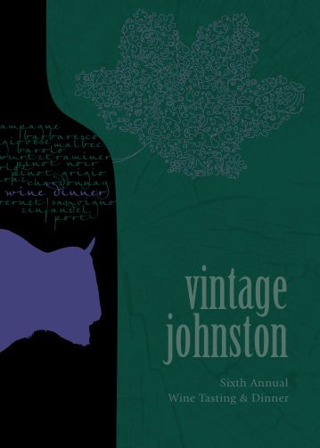

Perhaps the biggest alumni priority right now is the 45th reunion, which is getting closer and closer! After a successful brainstorming session last spring, the committee will be having its first organization meeting on October 13, 2012 in Holt Lobby. It just so happens that the 6th annual Vintage Johnston Wine Dinner will be held that very same day, so there’s even more reason to get yourself to Redlands! If you are interested in coming to the dinner, please contact the Development Office 909/748-8355, to reserve a spot. If you are interested in being a part of the reunion committee, and/or have any suggestions, please contact me directly (kelly_hankin@redlands.edu). In the meantime, rest assured that your wonderful co-chairs, Morgan Chicarelli and Matt Gray, are working hard to make sure the event is everything we all hope for.

From Bekins 112, I send you all my love and best wishes. As usual, please send any stories that you would like printed in future issues of The Coz to me. And make sure to check out the Johnston Facebook page, which is chock full of interesting news from alumni and the program.

Kelly

Introducing….the Graduating Class of 2012
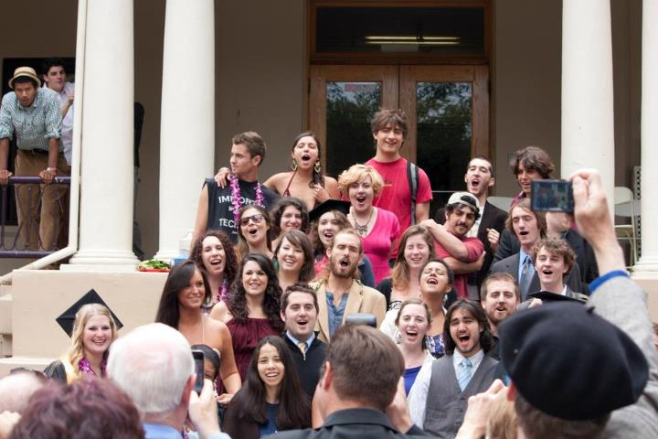

As usual, this year’s Johnston commencement was part burlesque show, part epic poem, and part love-fest. In typical fashion, we had animals roaming on the lawn, spectacles such as graduates getting pies smashed in their faces on stage, and presenters taking far more than their allotted two minutes to present students with their degrees! Kathy Ogren and Ben Aronson, who taught the graduating class in their Johnston First Year Seminar, did a lovely job as co-commencement speakers. And, even with our loosey-goosey timekeeping, we managed to get through the festivities in well under four hours! Also of note are the many Johnston students who were awarded during commencement week with Honors and prizes from the greater University. Lane Smith was awarded the “Outstanding Senior in Studio Art” by the Art Department, Rachel Reynolds, featured in this issue, was given the “American Academy of Poets Jane Burden Prize” in Creative Writing, Elliot Cavnaugh, also featured here, was awarded the “Colwell Prize for Excellence in American Politics” from the Government Department, Samantha Berkman was awarded the first “Outstanding Senior” award the new Visual & Media Studies major has ever bestowed, and the ASUR President’s Award went to Elyssa Kellogg. As you can see, Johnston really cleaned up when it came to awards this year. Not that we’re boastful or anything….

Here are a few commencement items of interest. First, The Coz features the requisite listing of graduates and their emphases. Of course, this is not in alphabetical order. Instead, graduates are listed by the zany system they unsurprisingly chose: graduates with the most number of letters in their emphasis title appear first, although if you read closely this clearly didn’t happen exactly as planned! Following this, we feature stories about two graduates—Elliot Cavnaugh and Ellen Parkin—so you can get a sense of the kind of work the senior class did and what paths they are currently embarking on. Finally, Jake Boyle, class of 2012, shares his reflections on his time as Community Director.

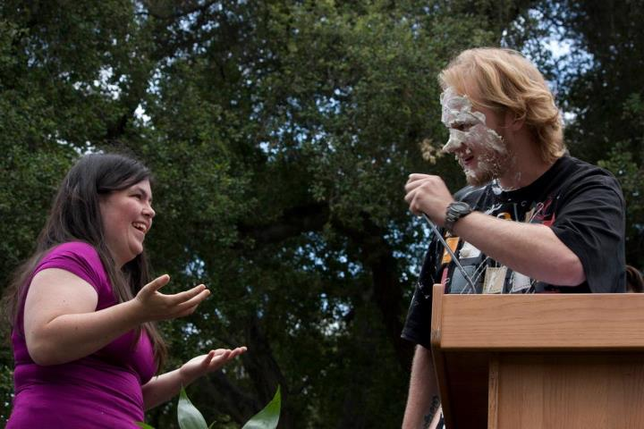
Jake Kandl, class of 2012, and Hannah Pope, class of 2015.

Kevin Ryan Murphy
The Mnemonic Francophone: Integrative Studies in History, Theory, and Production of Art with the French Language

Elyssa Rose Kellogg
Breaking the Cycle: Multicultural Studies in the Psychology of Family Dynamics and Troubled Youth

Tara M. Fulp
Conceptualizing Stylistic Identities through Fashionable Brand Management and Marketing

Megan Ryley Suster
Decorating My Time Machine with Flowers: Examining How History is Preserved and Presented

Alec J. Zurilgen
The Challenge of Learning: Expanding the Role of Video Games and Outdoor Education

Justin Phillip Jimenez
Communication Sciences and Educational Studies: A Hermeneutic
Approach

Anne DaSilva
An Artful Response to Injustice; Sociology, Psychology and
Art Therapy

Jacob Maxwell Brougham
Exploring New Sound: Finding the Individual Voice in the Craft of Song

Emma Kathryn Janeczko
The Components of Promotion: With a Concentration in Social Change

Philip Bouley
Sustainability and Development in International Agriculture

Sean M. Hughes
Currents of Change: Music and How it Embodies the Values of Individuals and Cultures

Alda Allina Migoni
Historiography of Latin America and Spanish Language Studies

Cindy Gilda Santander
Looking at Genetics through an Anthro-Linguistic Perspective

Erica Lee Sharp
Socio-Environmental Studies with an Emphasis on Population

Natasha Stein
Economic Politics with a Concentration in African Studies

Shiloh N. Drake
Modern Languages and Linguistics: For the Love of Words

Kathryn Ann Arthur
Social Entrepreneurship and Cause Related Marketing

Carisa L. Buchanan
Sustainable Agriculture and Latin American Studies
Caroline Stephanie DeBruhl
Logos: Philosophy, Spirituality, and The Written Word

Genevieve McAllister Lee Hayman
The Tangible and Intangible Aspects of Personhood

Ellen Jane Parkin
Food Science with a Concentration in Fermentation
Whitney Evalee Washington
Creating Change: Nonprofit Development and Programming
Jake Boyle
American Studies
Ella Marie McCann
Language as a Tool to Breakdown Cultural Barriers
Samantha Christine Berkman
Visual Literacy: The Aesthetics of Television

Benjamin Moroney
Cultivating the Arts through Design and Theory

Lane Stewart Smith
Cultural Equity Through Visual Art and Design

Alexandra Josephine Meadows
Visual Representations of Social Deviance

Matthew Eliot McBride
The Story of Wealth: Meditations on Motive

Elliot Roger Cavnaugh
The Art and Science of Creative Politics

Amanda Marie Parks
Business and Art for a Sustainable World

Ethan Tucker
The Craft of Song, Lyrics, and Storytelling

Sean Dugan Murphy
Music Production, Performance, and Technology

Lauren Hook
Economic Theory and Development

Andrew Bobroff
The Psychology of the Entrepreneur

Lauren Krystal Feldman
Psychology of the LGBTQ Community
Ryan Garigliano
Audio Engineering and Musicianship

Kylie Fligstein
Fashioning Self through Culture

Olivia Crowley-Sancrant
Language and Human Connection

Annabel Wynne Connelly
Environmental Humanities

Hallie Jordan Stern
The Ontology of a Performer

Jennifer Walsh
Philosophy and Education

Katherine Shriver Naugle
Experimental Education
Michael Francis Reilly
Environmental Economics
Michael Nicholas Crismali
Behavior and Humor

Scott Victor Dahl Leslie Lydon Being a Performer

Adam Ghovayzi
A Study in Pretending: Film, Theater, and Philosophy

Megan K. Cotter
Film and Culture

Andrew Evans Whitaker
World Building

Veronica Rose Nelson
Art and Activism

Jakob Kandl
Sound

Community Members: CAS students who were socially Johnston.
* Julia Slintak
* Marcella Landri

Ellen Parkin “Food Science with a concentration in Fermentation” (BA, 2012)

Ellen Parkin entered Johnston with a love of food and science, although initially she never thought to combine them together. As a first year student, she dove headfirst into difficult science classes, while at the same time exploring food history and culture. As she moved through her years, she continued her science education, taught a class called “Books That Make You Want to Cook,” and, in her capacity as manager of daytime Java coffee shop, she fed the community delicious delights with an emphasis on local and home baked goods. Somewhere along the way, it clicked for Ellen that the integration of food and science was what was most important to her. Ellen began working with Professor Ben Aronson, who has a great passion for beer-making, on the molecular science behind brewing. This relationship would prove fruitful for her. After returning from her study abroad in Australia, where she took upper level courses in Food Science, Ellen began working with Ben more closely. With Ben’s guidance, Ellen began working with our local brewery Hangar 24, conducting a senior research project on yeast attenuation to help the brewery discover why there might be a lag in the fermentation of their popular Orange Wheat beer. This experience led her to be chosen for a paid internship by the brew masters at Stone Brewery in San Diego. In her capacity as intern this summer, Ellen will be helping the brewery with the science side of their production. Ellen hopes to continue her education in Food Science at the masters level.

Elliot Cavnaugh “The Art and Science of Creative Politics” (BA, 2012)
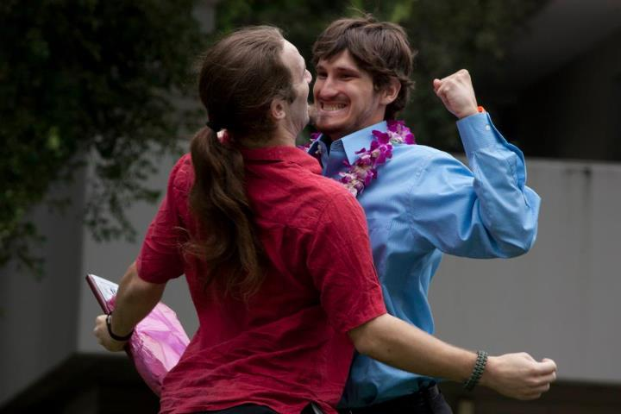
Elliot Cavnaugh (in the blue shirt) enjoys graduation festivities.

Elliot Cavnaugh was a proud community member. He was involved in all matters pertaining to the community, from academic policies to social planning. We thank Elliot for his clear love for the community and congratulate him on the success he has achieved from all of his hard work. What follows, in his words, is a little bit about Elliot’s time in Johnston, his emphasis and his future plans.

My emphasis is titled "The Art and Science of Creative Politics." It is centered on politics, with a core of government courses and a mix of interdisciplinary humanities and social sciences, particularly, literature, sociology and anthropology, and history. Basically, it is an emphasis that was designed to help me understand politics in the broadest sense of how people come together to make decisions. I've always known that I wanted to be in politics to work for real, meaningful change. So, I knew that I needed to understand issues of power and identity on a fundamental level, to see how that is expressed in the political process. In addition to my academic work, the Johnston community has been a huge teacher for me. Serving as Johnston Peer Council Director, Peer Adviser, Academic Policy Committee, and a member of Orientation Staff, and simply being actively involved in Johnston throughout my four years here has taught me the importance of community, which has become a major part of my education. I also spent a semester abroad in the Findhorn Community, an ecovillage in Scotland committed to environmental and spiritual sustainability.

As for the “Colwell Award for American Politics,” it is given once a year by the Government Department to a student who shows excellence in the study of American politics. Apparently that's me? American politics has been a major part of my emphasis that I've studied in a variety of different ways, including through the Government Department in courses such as “Political Parties Elections and Congress.” It is also something that I have worked hard to integrate into other classes outside the Government Department, such as in my course on “Lost and Found Generations in Interwar America,” and “The Sixties” with Kathy Ogren. I haven't heard of any other Johnston student who's gotten the award, maybe this is the first time? Either way, I truly appreciate it. The Government Department has played a huge role in my education here, and I am so grateful to all of my professors for all of their work over the years, and for giving me this award.

The program that I've been accepted to is called the “Capital Fellows Program.” It's actually four interconnected programs, each of which operates in a different section of the California government. The specific program that I have been accepted to is the “Jesse M. Unruh Assembly Fellowship,” there's also the Executive Fellowship, the Judicial Administration Fellowship, and the California Senate Fellows. Each of these programs places a small amount of students in the California State Assembly, Senate, Executive, or Judicial branch (there are eighteen fellows in my program). Each fellow is assigned to a full-time position in his department; I will likely be assigned to the Sacramento Office of an Assemblyman or Assemblywoman to work on their professional work. This can include anything from drafting legislation, analyzing bills for committees, interacting with constituents, writing speeches, and conducting policy research. Needless to say, this is a lot of responsibility, and I feel incredibly privileged to have this opportunity, especially immediately after graduating from Johnston.

At the same time, I will be earning graduate credits through seminars taught by professors at CSU Sacramento. This combination of academic work with hands-on experience is one of the reasons why the program appeals to me so much, and I know that my Johnston education will be vital in dealing with the complexity of real-world public policy issues. If you want to check out the website, here it is: http://www.csus.edu/calst/assembly_fellowship_program.html

Jake Boyle: Community Director, 2012

I haven’t been the Johnston Community Director for twenty-six days. I find this fact distressing. It’s been a rough transition for me these last few weeks, pivoting from being whole-heartedly involved in the Johnston Community to not being there at all. One of the parts of the job that was both a blessing and a curse, was the fact that I was required to stay after graduation for a full week, cleaning complex and getting other affairs in order. I worked straight through until the morning I left when, as I anxiously waited for my ride to the airport, Denise Davis called me into her office to go over the missing key list one last time. Being a CD or a CA is one of those jobs that if you’re doing it right, you can never stop. I learned this from watching my friends who had previously served on the C-Staff: the moment they stepped onto complex they couldn’t help but reprise their old roles, even long past their graduation. Being required to stay an extra week was, as I said, a blessing and a curse. It was a blessing because it gave me a few more nights with the murals on third floor and a few more mornings on the Bekins porch. It was a curse, however, because I lost the ceremonial closure that comes from graduation. It’s never easy leaving a place you love, but one moment I was there and, suddenly, I was back in Chicago looking for a new job. How do you look for work after you’ve just finished the best job you’ll ever have? Are there any intentional communities in Chicago with jobs available? Are there any intentional communities in Chicago?

Don’t get me wrong, I love being in Chicago. Returning home has given me a new context on Johnston, because for the first time in four years I have an opportunity to view Johnston from an outside perspective that I am familiar with. I know the people here as intimately as I do Johnston folk and being able to compare and contrast both worlds has been invaluable. Very well-intentioned and kindhearted people here have a tendency to refer to Johnston as an “alternative” school, as opposed to more “normal” colleges like the University of Illinois or Northwestern. I may have had a few too many servings of the Johnston Kool-Aid, but in my mind Johnston is the most normal place on earth. Normal is where a man can wear a dress and not be treated like a freak, or a woman can walk around naked and not be treated like a sexual object. Normal is where students study for the love of intellectual curiosity instead of cutting corners to receive higher rankings. Everything else is alternative. Certainly there are some in the Johnston Community who don’t think everything that happens on the Bekins Porch around four on a Friday morning is technically “normal,” but even still, the mark of a true Buffalo is some one who feels deep in their heart that, “I dinna care what you’re doing, so long as you’re having a good time.” Johnston teaches us that the only standard of normality for human behavior is a respectful acceptance and love for another person’s sense of normality.

Which is where my role as CD comes in. In a letter congratulating me on my graduation, my grandfather paraphrased the recently deceased scholar Paul Fussell who noted that, “it is well to know exactly who you are, so you can conduct the rest of your life properly.” In my mind, my job as the Johnston CD was to facilitate an environment where we could all learn exactly who we were. Johnston requires us to unhinge ourselves and go exploring what we perceive as our limits. Once you start doing this, you learn that your limits don’t exist and you can take yourself wherever you want to go. You also learn that life beyond the edge can be very dangerous and unsustainable, but you need to get there first. I found my job as a CD wasn’t to keep people from falling off the edge but to help them back safely. One of the hardest lessons I learned was that I needed just as much help climbing back up as every one else. When I found occasion to fly off the edge, there were always loving hands to guide me back to safety.

It was these loving hands that really made being CD a special experience. I was blessed with a staff of the most loving and devoted CA’s the community could have asked for. Their passion for Johnston was unsurpassable and I watched them fight tooth and nail for their community every day for nine months. I’m not being facetious or hyperbolic when I say that they sacrificed their own physical and mental health for Johnston. I’m overjoyed that one of them, Phil Jackson, will be taking my place in the newly branded role as Community Coordinator next year. The name may have changed, but we’re lucky to have Phil in this role next year.

I can’t write a conclusion for this. What an obvious metaphor.

Introducing President Kuncl!
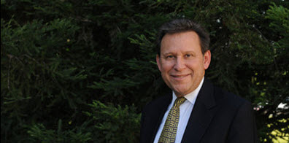

By the time you read this, President Ralph Kuncl, the 11th President of the University, will be situated in his office, hard at work. Formerly the provost and executive vice president of University of Rochester, President Kuncl succeeds retiring President James R. Appleton. All of us in Johnston—faculty and students alike—are eager to get to know President Kuncl and introduce him (okay, inculcate him) in the ways of Johnston. For more information on President Kuncl, see
http://www.redlands.edu/about-redlands/11842.aspx

Introducing our newest community member: Sarah Vilardo

This fall, we’ve added a new staff position in Johnston—the Resident Hall Coordinator. As the RHC, Sarah will work with Student Life and Assistant Director Denise Davis to take care of all things related to the complicated process of “housing placement.” Sarah will also work on programming for the community. Sarah has only experienced Johnston on her interview, so we’re all excited for her to experience her first community meeting, community dinner, Orientation week, GYST week, etc. A recent graduate in Women’s Studies from UC Santa Barbara, Sarah is a welcome addition to the community.

NEW EXPERIENCES MEET THE 2012 JOHNSTON OAXACA/GUATEMALA INTEGRATED SEMESTER
By Patricia Wasielewski

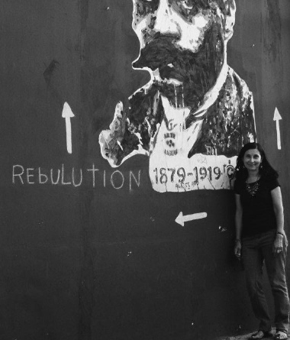

An intrepid group of students completed the fourth version of the Johnston Integrated Semester in Oaxaca, Mexico and Guatemala and the companion May Term Course “Revisioning Oaxaca/Guatemala” this past spring. Two assistants, both alumna of the trip, Kristin Smith (2008) and Caitlin Hamilton (2006), brought their considerable talents and rounded out the group, that is lead by Pat Wasielewski, professor of Sociology and Anthropology and Women’s and Gender Studies and Johnston affiliated faculty.

One of the most exciting things about the Integrated Travel Semester is that each time new contacts and interests make it unique. The 2012 group started the semester by spending a week in Mexico City and then another week in San Agustin Etla, just outside of Oaxaca, at a retreat. Our educational partner in Oaxaca, the Universidad de la Tierra, and its director, Gustavo Esteva, arranged both weeks. Gustavo has long advocated and written about alternative education. The philosophy of UniTierra is to provide advanced education in areas of student interest for those from rural communities that can’t attend University. Their programs range from urban gardening to community radio production. It is a nice parallel to some of the founding ideas of Johnston College.

This partnership provided a lot more background information about Mexico and Oaxaca from Mexican academic sources and also gave us direct contact with a variety of community groups surrounding Oaxaca and in the Isthmus of Tehuantepec. We were able to stay for the weekend in homes of weavers in a cooperative working in Teotitlan del Valle, and later in the semester, when we traveled to the coast, we ended this trip by going down to the Isthmus and meeting with groups working to harness wind power and generate electricity for their own communities. We also visited the largest immigration receiving facility for those from Central America—think “Sin Nombre”—which is located on the train tracks headed north. We also had the opportunity to meet with a woman who spoke about the women of Tehuantepec and their supposed “matriarchy” and with a trans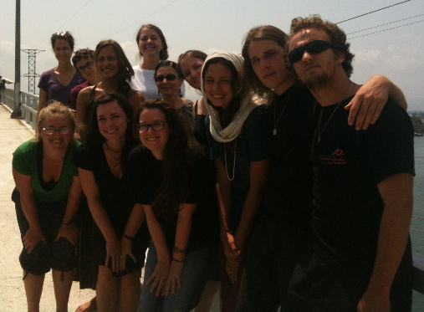

gendered woman (muxe) who heads the primary AIDS project in the area.
The group spent a week hiking and traveling through the communities of the Pueblos Mancomunados. Each time she goes Pat get’s more optimistic about hiking—this group hiked approximately 32 kilometers (almost 20 miles) over the 5 days. On one of the most brutal of the uphill segments, assistant Caitlin Hamilton provided encouragement by reminding us of Michael Phelps—if he could win so many gold, we could make it up the hill! Along with baking bread and seeing how to make pulque (a fermented agave beverage), we spoke with curanderas (natural healers) and ate trout from their community farms.
An added feature this year was that the group got to spend a week at Tierra del Sol, a permaculture farm just outside of Oaxaca in Tlacochahuaya. Pablo and Adrianna Lavalle started the farm about 10 years ago and now host groups to educate people about permaculture principles. While on the farm the group cut alfalfa, learned how to create organic compost, planted with local school kids, and helped create a mud yert for one of the farm’s neighbors. The group now has the skills that it could easily make the connector building between Holt and Bekins if we can find enough carrizo (medium sized bamboo-like plants) and clay.
Our trip to the beach was enhanced with time by working with Carlos Rivera, a local Oaxacan guide who used his various connections to help us visit many community projects along the coast. This time instead of just visiting the turtle sanctuary we talked to two community conservation groups and released sea turtles we saw emerging from their eggs. We also visited the community of La Pastoria where a group of Afro-Mexican men and women are recuperating the skill of making sea salt naturally as their ancestors did in the 1800’s. We were the first group this community has hosted as part of a new ecotourism project. They are also one of the two communities that this group chose to send the resources we made in our May Term presentation through the auction and raffle.
All the additional travel and experiences made for an exciting and fast paced semester. There was still the regular work of the Spanish and Zapotec language classes, Pat’s class on “Tourism, globalization and development” and the various internship placements. This group had many artists in it: one, Jakub Kukla, worked with the graphic artists at the ASARO collective—one of the groups that provided artistic voice to the 2006 Oaxacan uprising. Another of the artists, Ziza Craig, worked with children using art to explore contemporary Mexican issues at the Casa de Cultura. Anne DaSilva and Rachel Linares worked with Casa de Esperanza combining art and therapy for the street children’s program. One of the most exciting and unexpected internships turned out to be the one Kari Bush got; a classically trained musician, Kari ended up playing with the Banda del Estado de Oaxaca—or the State Band which is the equivalent of the local symphony. We also had those with primary interest in environmental studies, including Monty Aguilar, who worked weekly at the permaculture farm mentioned above, and Devin Wright, who worked at Instituto de la Naturaleza y la Sociedad de Oaxaca—a group dedicated to conservation of natural resources and traditional communities. Virginia Osterman pursued her interest in natural healing and medicine by studying the traditional temescal (sweatlodge) and Dillon Dobson worked with a local migration center.

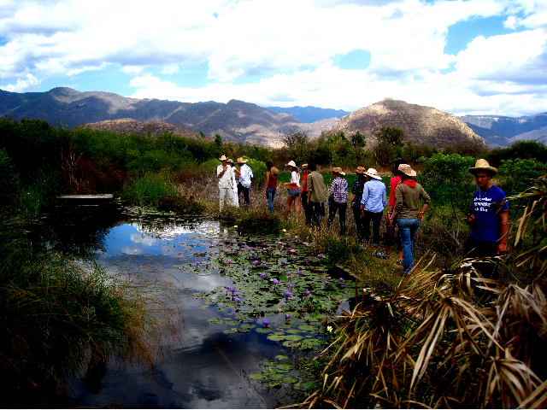
The trip to Guatemala this time was also different in that we did not return to Quetzaltenango, but worked with the Centro de Investigaciones Regionpales de Mesoamerica in Antigua. Along with spending Easter in Antigua, the group also studied Spanish there and made great chocolate candy and drinks in the new Chocolate Museum. Trips to Chichicastenango and Lake Atitlan—staying in Santiago Atitlan--were also a part of this trip. But, perhaps the most interesting and different part of our activities this time was a 4 day excursion to Rio Negro, in Baja Verapaz. This is a community that was hard hit by the violence during the civil war—an estimated 400+ of their residents were killed in 4 different massacres. The survivors and their children are now developing this area into a remembrance and ecotourist site. This was a very powerful set of days where we hiked the route up a hill and into a ravine where 170 women and children were killed. Our guides were young men who had survived that day. We also hiked the next day to where some who escaped managed to live in caves, sometimes for up to 3 years, in order to survive. This is the second community the funds from May Term were designated to help. From Rio Negro we traveled overland up through the Peten to Tikal. Although the drive was beautiful, over 12 hours in the van convinced Pat to always fly!
The group returned to Redlands full of great ideas and things to share. We now have a mural on second floor Bekins, just outside of Pat’s office, which the group worked on to visually represent the semester. The community presentation changed venues to the Alumni House garden. The group was the first to successfully have an outdoor presentation using tents. The auction and raffle and presentations made for a full event. Of course, Mama’s Hot Tamales of LA, provided what Bon Appetite couldn’t!!
The next group is scheduled to go in the Spring of 2014. Anyone who has been on the trip and would like to take a shot at being an assistant should contact Pat. Recruitment of the students begins this fall!!!

Back by popular demand…the second annual What We’ve Been Reading Over the Summer…

Penny McElroy: Red Brick, Black Mountain, White Clay by Christopher Bentley, The Hunger Games by Suzanne Collins, Extremely Loud and Incredibly Close by Jonathan Safran Foer recently. I’m just beginning The Sound and the Fury by William Falkner. Moonrise Kingdom is at the top of my "must see" movie list.

Tim Seiber: I traveled to an island this summer, so I read books set on islands. I had two: Kurt Vonnegut’s Galapagos and Henry Miller’s The Colossus of Maroussi.

Fred Rabinowitz:
Guns, Germs, and Steel by Jared Diamond
One of a Kind: The Rise and Fall of Stuey The Kid Ungar, the World’s Greatest Poker Player by Nolan Dallas and Peter Alson
Liar's Poker: Rising through the Wreckage on Wall Street by Michael Lewis
Cowboys Full: The Story of Poker by James McManus
Mystery by Jonathan Kellerman
South of Broad by Pat Conroy

Alisa Slaughter: Joan Retallack's The Poethical Wager. It is about John Cage, Gertrude Stein, and other practitioners of experimental literature, and it kept my brain very busy.

Leslie Brody: Off the success of her excellent biography of Jessica Mitford (Irrepressible: The Life and Times of Jessica Mitford), Leslie shares with us some of her favorite nontraditional biographies.

Footsteps: Adventures of a Romantic Biographer by Richard Holmes
Holmes takes similar journeys to those of several Nineteenth Century travelers, writers and thinkers like Robert Louis Stevenson and Mary Wollstonecraft; writing of their stories as his own unfold. I can’t think of a better book than Footsteps for capturing youth and early ardent devotion in both author and (multiple) subjects. I love the way Holmes comes to recognize how submerged he is in his work when one day he dates a check 1772, instead of 1972.

Daisy Bates in the Desert: A Woman’s Life among the Aboriginals by Julia Blackburn
The author brilliantly inserts herself into this biography about an unreliable, elusive subject, who became an Australian legend. The language is sumptuous, the form original and the story unpredictable and satisfying. What a character!

Voltaire in Love by Nancy Mitford
A joint biography, history, love story about two of Western civilizations greatest and most original thinkers: Voltaire and scientist Emilie de Chatelet. It is charming in every sense of the word. You often feel, reading this book, as if you’re moving through a salon of brilliant friends and frenemies. Here’s critic Raymond Mortimer on Mitford’s narrative style, “so peculiar, so breathless, so remote from what has ever been used for biography. I feel as if an enchantingly clever woman was pouring out the story to me on the telephone.”

Six Exceptional Women: Further Memoirs by James Lord
These memoirs are portraits of Gertrude Stein, Alice B. Toklas, the actress Arletty and others Lord met on the way from innocence to experience. Lord is chatty, gossipy, erudite and gleaming. How does he do it?

Flush by Virginia Woolf
Elizabeth Barrett Browning as perceived by her beloved cocker spaniel creatively documents the human condition. I wish Woolf had met my dogs Alphie, Ole, and Woody. (Editor’s note: this is one of my all time favorite books.)

Ben Aronson: Julian Barnes’ The Sense of an Ending and David Foster Wallace’s
“Consider the Lobster” (my first attempt at reading DFW).

Pat Geary: Karen Russell’s Swamplandia!

Kelly Hankin: This summer I’ve loved, loved, loved: Julian Barnes’ The Sense of an Ending, Marcy Dermansky’s Bad Marie, Patrick deWitt’s The Sisters Brothers, and Ann Patchett’s Bell Canto (why it took me so long to read the latter I’ll never know). On the tube, I’ve been obsessed with the Danish police procedural Forbrydelsen.

Patricia Wasielewski: Just for fun I started out the summer reading Sara Paretsky's newest
mystery novel, Body Work. Who wouldn't love this Polish-Italian middle-aged PI in Chicago who keeps on solving those tricky cases—this one involves a soldier with PTSD, an performance artist who lets strangers paint her body, and crooked military contractors. At the same time I was feeding my non-fiction side with Alexandra Horowitz's
Inside of a Dog: What Dogs See, Smell, and Know—while I learned a lot, my own dogs still remain a mystery to me. Currently I am reading The Night Circus by Erin Morgenstern. Every source where I read book reviews recommended this and so far the story of two magicians in training is intriguing. Finally, I am reading Javier Sicilia's book Estamos hasta la madre. This expression in Spanish means being fed up to the highest degree (polite version!). Sicilia is a Mexican poet and social commentator whose son was killed last year by drug gang members. After his death, Sicilia wrote an essay, and now this book, to condemn both the drug cartels and the government for being unable to stem the violence. It is currently only in Spanish, but gives voice to millions of Mexican's ideas about drug legalization and what role the government might play and its relationship to the U.S. "drug war."

Julie Townsend: I've been reading up on Josephine Baker and Modern Dance Theory this summer. Favorite titles so far include: Second Skin: Josphine Baker & the Modern Surface by Anne Cheng, Choreographing Empathy by Susan Foster, and Alien Bodies by Ramsay Burt.

Kevin O’Neill: I am currently reading Richard Ford's Canada, a very slow, very sorrowful and deeply elegiac work that I highly recommend – but you need patience. 1Q84 by Murakami is intense and complex and worth the time investment. HHhH is odd, fascinating, very very postmodern and can be both aggravating and powerful. The Violinist's Thumb is first rate popular science writing about genes. Very cool and worth the read.
So is Stephen Jay Gould's Full House, about the illusions that surround our ideas about evolutionary progress; of course, John Williams' rediscovered wonderful novel from the 1960s, Stoner, which I have just started. Finally, for fun but also because it really captures the diction and mood of Southern California's beautiful amorality, Winslow's Savages, which just came out as a movie, which I have not seen. Winslow has mastered 21st century SoCal noir like no one else. Finally, finally, I really enjoyed re-reading Lucretius' Nature of
Things for my turn at the alumni Asilomar seminar. As you can see I probably read more than I should.

Unsolitary Reading

Speaking of reading, the Buffalo Books project has finally found its groove. When it first began, it used the online Ning site as its platform. This turned out to be too complicated for a lot of readers who wanted to participate, but didn’t want to log in to yet another online site. Facebook turned out to be just the ticket. Now, a nice group of readers has joined on the Buffalo Books site, which is just a click away on the Johnston FB page. If you’re interested in unsolitary reading, a lively discussion is just a click away. What follows is a description of the BB group, along with a parallel reading group, by active reader and BB contributor Bill McDonald.

Once we all realized that the seven novels of In Search of Lost Time was not exactly the best place to begin an online book discussion for busy working alums, Buffalo Books scaled back to more manageable "world literature" novels—Tayeb Salih’s Season of Migration to the North and Caryl Phillips’ The Nature of Blood under the leadership of Sandy Shattuck (1977) and Jane Creighton (1973)—and then scaled back again to even more manageable short fiction: Edwidge Danticat's edited volume Haiti Noir. With Danticat we also switched our discussions from our Ning site to the more easily accessible Johnston Facebook page. There, with Pat Harrigan (1994) taking the lead, we Buffalo Bookers are just beginning (August 1) a collection of short fiction from Iran: Strange Times, My Dear. It's available from several on-line book vendors, and can be purchased on Kindle for practically nothing. Already fresh voices are joining in, and new members are always welcome!

In a parallel adventure a dozen or so fearless alums, mostly from the Bay area, took up the new Pevear-Volokhonsky translation of War and Peace which I was teaching on campus last spring, and finished it at the beginning of summer. They gathered for discussions at several "Russian dinners and soirees" organized (mainly) by Emily Wick (2000). There may be other groups out there, reading away: let us know!

The 2012 Johnston Summer Alumni Seminar

In June, Bill McDonald and Rachel Reynolds, class of 2013, led a summer seminar at Asilomar (Pacific Grove, CA) on Ovid’s complete Metamorphoses. Having just returned from my trip to Croatia, I opened my inbox to a series of heartfelt evaluations on the meaning and significance of the trip for alumni. I’ve read a lot of beautifully written, richly evocative, and deeply personal evaluations in my time, but there is something about the evaluations from the seminar that greatly moved me and truly made me feel the power of the class. With their permission, I reprint several here. But first, I start with thoughts from both Bill McD and Rachel Reynolds, who JC thanks wholeheartedly for the gift of their time, intellect, and passion.

ON READING AND TEACHING METAMORPHOSES
By Bill McDonald

Our 2012 alumni seminar began with a wish. I wanted to read, for the first time, Ovid’s complete Metamorphoses with a group of undergraduate, then alumni readers. Discussions led to a generous offer from an anonymous donor to support part of the cost for such an alumni gathering at Asilomar in Monterey. Soon thereafter I met Johnston undergrad Rachel Reynolds, an accomplished Latinist and Ovid-lover, and the idea of teaching such a course together took hold. Planning was minimal and focused on several evening events. Kevin O’Neill agreed to speak to us about change in Greek and Roman thought, I offered a semi-formal lecture entitled “’Narcissus‘ Now and Then,” and Sandie Bacon (JC, 1975) volunteered to lead us art neophytes through a spontaneous collage project based on famous paintings of the poem’s narratives. We also scheduled an evening for “Ovid in opera” and an “open mike” night for individual performances of the poem, and of works based on it, both serious and silly. For our daily morning and afternoon two-hour classes we built discussion agendas for each, and negotiated the topics for the next meeting at the end of the previous one. That’s all the structure there was.

I knew well all of the alums who signed up for our week in June, but even a congenital optimist like myself didn’t anticipate how good our concentrated week morphing with Ovid would be. As with the Coetzee/Disgrace project we had no trained Ovid scholars. But we had everything else: seventeen brilliant and passionate reflective readers, extraordinary and effortless group process, an inspiring young classicist-in-the-making, a common history in the love of books and reading them together. Everyone without exception proved masters of “riffs” and “footnotes” and “variations” on each others’ ideas because everyone listened intently and honored what they heard. The level of interpretation could stand with any, and the openhearted emotions that the poem called forth from us made every session as full of feeling as it was ideas. And maybe best of all, every session was also full of laughter and celebration—of Ovid’s labyrinthine narrative, and of each other. It was a Wit Carnival, with hardly five minutes passing without sheer fun in one another’s humor adding to the inspiring quality of our reading.
There was one late morning, as ideas came thick and fast, when I suddenly realized that I could shut my eyes and recognize virtually every person in the room simply by their voice, a voice that I had first encountered in our classes together decades earlier, and whose timbre came back across the years with epiphanaic clarity. More than three decades of time and a hundred seminars collapsed, for me, into a single perception of Johnston continuity and unsolitary reading. It was my best moment in one of the best seminars I have ever been a part of.

We’re already planning a June 2013 seminar, led by Kevin and his wife Dorothy Clark, who teaches literature at Cal State Northridge. We’re hoping that these will become annual events in non-Reunion years: another piece of the alumni organization we’re building to support the Center and to celebrate what it has made possible for all of us.

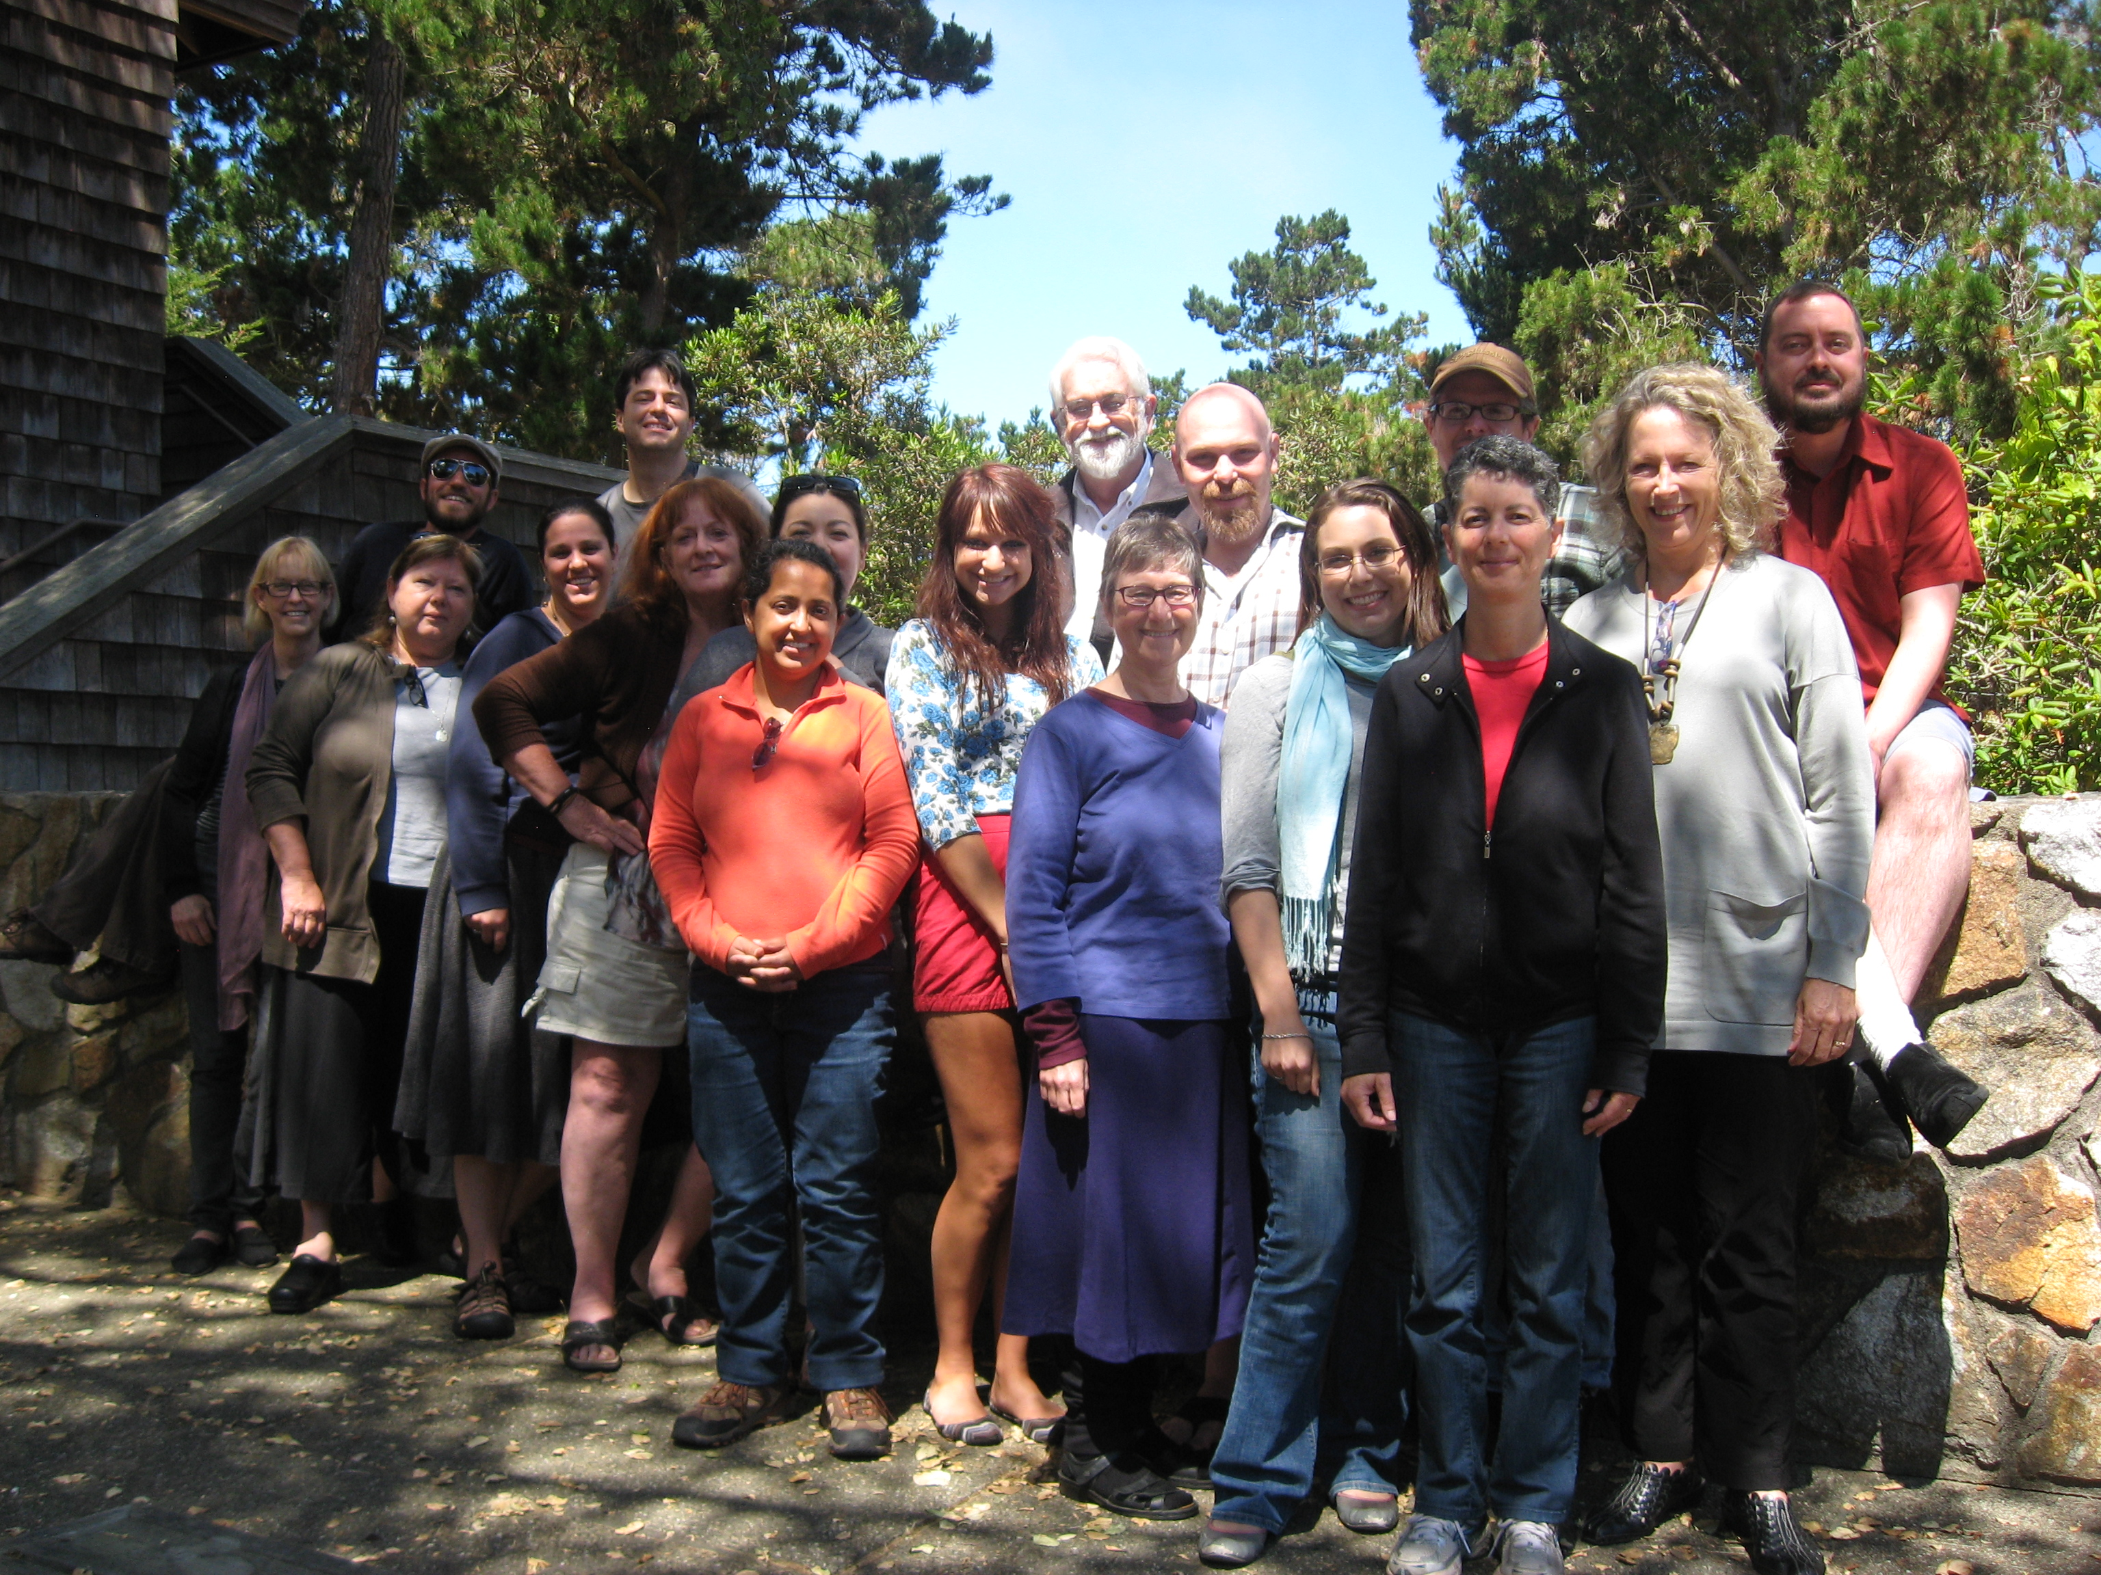
Johnstonians from all different generations know the power of unsolitary reading.

ON READING AND TEACHING METAMORPHOSES
By Rachel Reynolds ’13

When, as a freshman in the fall of 2010, I began translating excerpts from Ovid’s Metamorphoses—I’d taken Latin in high school and loved it—I had no idea it would lead to my co-facilitation, in 2012, of a Johnston May Term course on the subject. Scanning those first few lines of “Pyramus and Thisbe” (Ovid’s Romeo and Juliet) in my Latin reader that fall, I could not possibly have anticipated its culminating in my participation in this year’s Johnston Center alumni retreat, a one-week intensive, JC-style seminar led by Bill McDonald on the selfsame topic—the Metamorphoses of Publius Ovidius Naso. I have Johnston to thank for the opportunity, and in particular, the anonymous donor without whom the seminar—and my small contribution to it—would not have been possible.

Metamorphoses the course, co-taught by Bill and myself in May, arose out of a desire on his part simply to read the poem in its entirety, and on my part to try my hand at teaching the Classics—and in particular Latin poetry—to undergraduates, a career I plan on pursuing after college. Though our students had no prior experience with the language, I thought I could find a way to make the poem accessible—and even interesting! —to them in its original Latin. But first I’d have to show them why any of it—why, in fact, all of it—mattered. I decided to highlight three especially interesting aspects of the poem: the scansion of the first three lines; the translation of the last four lines; and the various rhetorical, literary, and poetic devices Ovid chooses to make use of throughout. In each of the three “Latin tutorials” I gave throughout the term, I tried to emphasize especially the transformative nature of the text, and, to my great delight, students responded with interest and even enthusiasm.

One of the best moments for me as a teacher was when, tentative during those first few days of teaching, I brought in an idea I wanted to share with the class. My idea concerned the use of point-of-view and perspective in the poem, particularly in its first five books. I came up with a list of about ten “ways of seeing” and examples of each from the text (among them ‘revelation’ in the story of Semele, ‘reflection’ in that of Narcissus, and ‘voyeurism’ in book four’s “Salmacis and Hermaphroditus”); these I listed on the board one day in class. To my surprise the students jumped at the idea, and together they helped me come up with ten, then twenty more “ways.” Some of them, like ‘petrification’ in Medusa’s case and ‘double vision’ in the case of the blind prophet Tiresias, I hadn’t thought of, and probably wouldn’t have thought of, without their help. The topic became a touchstone for us as we continued, with students contributing new “ways of seeing” in the weeks that followed. The experience changed my way of seeing myself as a teacher, and my students as colleagues and co-learners.

Bill and I began the Metamorphoses with an introduction to various ways to read the poem, chief of which was his rather stunning insight that the poem could be read—and perhaps should be read—horizontally. That is, that the characters in the poem displayed a psychology predating our modern preference for notions of depth and the buried inner life, by which their desires could be mapped on a single, surface-level plane. To read in this way required a great deal of our undergraduate readers, who had first to set aside notions of depth-as-meaning, then learn to read spatially—that is, to look to a character’s psychological periphery, rather than the stratified levels of his or her subconscious, for meaning. (There is no unconscious in Ovid; there is only consciousness, and it is not causal—it simply is.) Bill challenged the class not only to apply this technique to their reading of the Metamorphoses, but also to attempt a similar kind of thinking in their own lives. Their attempts to do so pushed them far beyond the limits of the classroom, and enhanced their thinking about the text considerably.

Having had success with them in our May Term course, Bill and I brought these same ideas with us to the alumni retreat in June. The seminar, held at Asilomar Conference Grounds in Monterey Bay, California during the week of June 23, drew alums from as far east as Albany, New York and as far west as San Jose, and included graduates from 1975 to 2005, with every decade well represented. Our days there were broken up into two, two-hour sessions in which we read and discussed sections of the poem, using a list of topics we’d generated together, and one longer evening session involving lecture, performance, and the arts in turn. Meals provided by Asilomar, and wine by both Bill and winemaker Wes Hagen ’91 of Clos Pepe Vineyards and Estate Wines, gave alums an opportunity to connect outside of class, as did afternoon excursions led by Bambi Brown Schmidt ’75 and evenings spent in conversation by the fire or over wine.

Lectures on “‘Narcissus’ Now and Then” by Bill and the history and philosophy of change by special guest lecturer Kevin O’Neil informed our discussions for the week, while presentations by Bill and myself on Ovid in art and music throughout the ages introduced new mediums by which to encounter our subject. A delightful evening of Ovid-inspired performances finished off the week, with group members contributing everything from song and dance numbers to dramatic monologues and readings of stories and poems “after Ovid.” An especially talented group of readers and artists, participants lent their skills to the making of a better seminar in more ways than one. One such contributor, Chicago-based artist Sandie Bacon ’74, led the group in the making of multimedia collages to express the transformative nature of the text, while recent graduate Matt Gray ’05 gave an impassioned tour of nearby Cannery Row, complete with readings from Steinbeck’s novel, as metamorphic a town—and a story—as any.

As an undergraduate among alums, I had to learn how to teach to a much different audience than before (these were not the college freshmen of last month’s course), an exciting challenge for me as a new teacher. But what I found was that, as before, what mattered most was that I loved it. My absolute investment in the course and its material was what counted, and what made students—alums or undergrads—want to invest themselves, too. I was, of course, immensely aided by the fact that alums were equally as invested in their own areas of interest and academics, and were able to bring with them their unique experiences “since Johnston,” lending their expertise on subjects as diverse as religion, politics, literature, agriculture, education, and the arts. Their contributions, which crossed disciplines and spanned generations of Johnstonians-in-the-world, made for a more illumined and informed discussion, and, ultimately, a more successful seminar.

Infinitely more important than their differences, though, was what the group had in common—a history and an education that had become for them a tradition to be upheld long after their graduation from Johnston. Nearly all of the alums had taken classes from Bill, a fact that became immediately apparent as we began reading. Having worked with Bill myself in the context of the Metamorphoses, I knew the way in which he is able to guide students towards a better understanding of themselves as readers, enhancing in this way their experience of the text. And indeed it would have been hard to find a more sophisticated group of readers than were gathered that week at Asilomar. As an observer of their interactions and an inheritor of that same tradition, I had the unique opportunity to see the fruits of a Johnston education in action, to see community recreate itself time and again as alums re-remembered their roots in the Johnston community, which they’d help build together, and which had set the model for all future encounters with groups like ours, hoping to learn something from one another.

What I learned was a great deal about my heritage. Academics aside, I’ve had trouble, in past years, connecting with the Johnston community. A serious student (perhaps a little too serious at times), I’ve had difficulty maintaining friendships, and making time for a life in the community. But joining together with alums from across the country to celebrate our love for Johnston and what it gave us, for Bill and all the other teachers who’d changed us, for “good conversation about a good book”—I came to understand just how special a thing it is to be a part of a community like Johnston. Despite my age, I felt entirely at home with the alumni gathered that week at Asilomar. If nothing else, I knew, we shared a small piece of our history in Johnston. And that was really something.

Reflections on the Ovid Summer Seminar

Ovid-worthy Metamorphoses, a Seminal Seminar By James O’Donnell III (1995)
In the final days before my wife and I headed to Asilomar for the first-ever Johnston summer seminar, the atmosphere in our little home was thick with excited, nervous energy and anticipation. We would soon undergo a rigorous, weeklong academic discussion of a text and poet with which neither of us had any particular previous experience -- and we would be sharing the experience with: the professor I admired more than any other I’d encountered as a student (the simply fantastic William McDonald); and Kevin O’Neill (a legendary Johnston professor I had not been lucky enough to have as an instructor); and a roomful of amazing scholars, including a remarkable young Latinist, Rachel Reynolds, and a few individuals I already knew -- and revered, frankly, for their extraordinary success as readers and Johnstonians -- from my time at Johnston, nearly 20 years ago.
Jennifer and I had both finished reading the 12,000-line, ~2,000 year-old Roman poem -- on schedule (which is to say with a few days to spare) -- and we were both committed to being constructive, earnest, hardworking seminar participants. Lacking anything resembling expertise in classical Roman poetry, we expected to do a lot of listening... but we also vowed to participate whenever we felt we had something useful to contribute. We wouldn’t be superstars, but we wouldn’t be shrinking violets, either. We would learn. It would be challenging. It would be great...
Just over a week since the seminar’s close, I can now say without the slightest fear of hyperbole that my wife and I had no idea how GREAT “great” could be -- this Johnston seminar was a life-changing, intellectually-galvanizing, incredible experience -- unmatched in either of our academically rich and intellectually stimulating lives. Bill, Rachel, and our fellow participants brought diverse and seemingly inexhaustible resources to this outstanding group effort (and Kevin’s “keynote” talk on Lucretius, the atomist philosophers, and Pythagoras was a stunning, brilliant tour de force, an incredibly efficient -- and extremely humorous -- presentation of classical notions about the structure of the universe).

Together we grappled with a beautifully unconventional (formally, and in other ways, subversive) and historically vital epic poem of considerable (unplumbed, shall we say?) depth and complexity, and made real progress in identifying many of the poem’s narrative arcs, some of the poet’s chief concerns, and advancing our understanding of who Publius Ovidius Naso was and what he thought he was achieving when he wrote his timeless masterpiece.
This (easily understated) achievement was accomplished through the most successful implementation I have ever witnessed of unsolitary reading and the Johnston model that has remained with me since I graduated in 1995. This model is exemplified by a roomful of genuine scholars who self-identify as students first and seek to learn from one another by practicing a thoughtful, humble, and respectful type of dialogue all-but-guaranteed to result in a productive and meaningful exchange. However grandiose all that might sound, there’s not a whit of exaggeration in these claims; this seminar was, in every sense of the word, OUTSTANDING.
Departing Asilomar, I came away with a much greater sense of Ovid’s work than I had going in (after a very close, ever-annotating read beforehand), and that increased understanding was very rewarding, indeed... but I also came away with an unexpected trove of other knowledge, terminology, and inter-textual resonances. Although listing some of the highlights here does no justice to the conversations in which the following terms and names appeared, I’m going to take a shot at it anyway, hoping that my reader can begin to imagine how appropriately and meaningfully contextualized the following syllables were during the seminar: Derrida, Freud, theodicy, Nietzsche, scansion, Lucretius, teleology, metempsychosis, Lacan, Shadi Bartsch, Democritus, Herodotus, ataraxia, Roland Barthes, semiotics, Joseph Campbell, James George Frazer’s The Golden Bough, John Steinbeck’s Cannery Row, and much, much more.
I also left the first-ever Johnston summer seminar feeling TRANSFORMED myself. However corny that might sound, Bill and Rachel (our seminar’s two co-facilitators) succeeded beyond my wildest imaginings, providing an extraordinarily inviting (and truly joyous, ultimately celebratory) environment for a group of serious-minded scholars to jointly explore an amazingly rich and influential source material, Ovid’s staggeringly impressive, beautifully affecting poem. They did so in a way that left virtually everyone (at least everyone with whom I spoke at our extraordinary week’s end) feeling not just elated with the results but personally CHANGED by the experience... and for the better, so much for the better.
I cannot actually express in words (nor can I yet fully appreciate) the abundance of gifts that I’m sure will continue to accrue as a result of my participation in Johnston’s “Ovid’s Metamorphoses” seminar. My work as an artist and writer will benefit, I’m sure, as will my work as a political activist. In short, I have benefited, as a human being -- and no doubt will continue to do so as a result of this experience. (Also, it was nothing short of wonderful to share this experience with my beloved wife; the only non-U of R participant in the seminar, Jennifer felt warmly welcomed from the start.)
Aside from feeling enormously grateful to Johnston (once again) for all that the school has given me, I feel that my connection to the University and the Johnston Center has simply never been stronger. The following two words have never seemed so inadequate, but they seem appropriate, nonetheless, and I guess I don’t know how to close this summary without them, so here they are: THANK YOU.

Reflections from Wes Hagen, Vineyard Manager/Winemaker (UR graduate in English and honorary Johnstonian, 1991)

Driving home from the Ovid Conference at Asilomar was a thoughtful and
reflective journey back to reality. I usually listen to music or a book on tape during long drives, but for that four hours I sat in silence. It had been an intense week and I wanted to let the silence envelop me, to speak to me, to finish the metamorphoses that Ovid and Johnston initiated.

If Confucius was correct, and admitting ignorance is wise, allow me to bring out of hiding a few large, flawless pearls. Before starting the 'Ovid Project', I thought 'Ovid' was a footnote convention like 'Ibid'. Without a single course in the Classics, I had to assume that anything so often embedded in a text could not be from a single author, but from a collection or library of classics that were described/annotated vis-à-vis a single
source. I did not know that Ovid was a single man and that the Metamorphoses was an encyclopedia of Greco-Roman myths and parody spinning in elegiac, dactylic ellipses around Augustus, Virgil, and even around the Gods themselves.

Bill McDonald's introduction and Kevin O'Neill's masterful 'keynote speech'
were individually worth the price of admission for the entire week, and changed my world view and my moment-to-moment understanding of who I am. The dynamic Johnston duo, in only a few hours, defined the rung of the ladder I am climbing to gain purchase on the shoulders of giants. We take for granted that the Greeks and Romans shaped Western culture--but it is humbling and intellectually stunning for the entire story to be told over 24
hours. My brain is still catching up.

I have lived in educational solitude for the last 18 years on a wine grape farm in Northern Santa Barbara County. I've kept up with my solitary reading of Frazer's [The] Golden Bough, religious texts and novels, but have been away from the type of unsolitary reading and intellectual conference and agency that was on full display for this week at Asilomar--the greatest week of selfish (I snuck away from work and my wife) and selfless (18 people making meaning) edification I have ever spent. I will not miss an opportunity like this--ever again.

This was my re-initiation into scholarship and a reminder of the profundity of my education at the University of Redlands. I am who I am because of Bill and Redlands--I am a lifelong learner who seeks enlightenment and to be proven wrong with equal zeal.

As the only non-Johnston student in the conference, I am most proud that I was made an honorary Johnstonite for the week. I take the honor seriously and will bring my light and passion to the world--a beacon of humanity, like that quote I struggled to recall from Gatsby: "Sometimes they came and went without having met Gatsby at all, came for the party with a simplicity of heart that was its own ticket of admission."

And at the end of the southbound 101, as I retrieved some Thai food to
celebrate a reunion with my patient wife, the fortune from the cookie could
not have been more appropriate for my return from the enchanted forest (gold
turned to green curry): "You have at your command the wisdom of the ages."

Reflections from Nancy Best ’81

Most people go to seminars because they are enthusiasts of the seminar’s topic. They go to writers conferences because they are enthusiastic about writing; they go to diving clinics because they are enthusiastic about diving. But one thing I can say for certain, I did NOT go the University of Redland’s Alumni seminar on Ovid’s Metamorphosis because I was enthused about classic literature or about Ovid. In fact I knew almost nothing about Ovid nor about Ovid’s Metamorphosis. I went to the seminar because I wanted to reconnect with people I knew would be good readers and reassess my Johnston education. As an educator, I felt I could gain professionally by participating in a different pedagogic approach to reading. I wanted to see if I could become a better reader by joining the Johnston group’s exploration of an unfamiliar text.

My first readings in preparation for the week told me that Metamorphosis was a book about human beings who were changed by their encounters with the Gods. Good Protestant that I am, I was intrigued. After all much of my religious heritage revolved around the same idea, though in the Christian perspective one is hopefully saved rather than ruined by such an encounter. I had all sorts of questions about what I imagined Ovid’s project to be:

Under what context were people changed?
What metaphorical significance did the changes have?
To what extent were the changes merited or justified?
What did the different notions of transformation say about the values of the cultures which produced the myths?
Would I be transformed by a divine encounter in the woods of Asilomar?

I don’t know if we talked much about these in the seminar, but I enjoyed thinking about them before hand.

The seminar itself was much less fanciful and much more rooted in textual exegesis. Rachael did close readings, translating from Latin; Kevin generously dropped in and provided a philosophical context for the work; Bill talked of Ovid’s notion of love and desire—there not being much difference between the two for Ovid in Bill’s take of Metamorphosis. As a writer I was interested in how Ovid achieved a profluence or flow and whether other readers discerned any overarching patterns to the narrative as a whole. I was never disappointed in the variety of opinions offered up on these and other aspects of the text. They stimulated and enlarged my own reading. What moves me most is the overwhelming generosity of this group. Sitting here at home, I remember the individual gestures and kindnesses and gifts of each person; I think of that wonderful moment where Bill said he heard each of our voices, past and present, and I think I know what he means.

Because part of the purpose of this response is for Kelly and the alumni office to gauge the effectiveness of groups like this in developing strong alumni ties, there is no other gathering I’ve attended that has been so effective in doing this for me. I came away with strong positive feelings for the University for supporting the seminar; for Johnston’s pedagogy; for Bill and Rachel; and for a remarkably generous, funny, and gifted group of readers.

